A REPORT

ON

SUBMITTED IN PARTIAL FULFILLMENT OF THE REQUIEMENT FOR THE AWARD OF THE SKILL CERTIFICATE OF

**(Semester 5th)**

IN

**School of Computing skills**

BY

**Rikvender Singh rajawat**

**(210611S009)**

UNDER THE GUIDANCE OF

**Mr. Dinesh Kumar Chounhary**



**SCHOOL OF COMPUTING SKILLS BHARTIYA SKILL DEVELOPMENT UNIVERSITY, JAIPUR JULY 2022**

**INDEX**

|  |  |  |
| --- | --- | --- |
| **SR. NO.** | **CONTENTS** | **PAGE NO.** |
|  | INTRODUCATION | 1 - 2 |
|  | ABOUT PROJECT | 4 - 5 |
|  | KEY FEATURES OF SUNBLASTER | 6 - 7 |
|  | BENEFITS OF SUN BLASTER | 8 |
|  | PROBLEM FACING | 9 |
|  | REQUIRED COMPONENTS IN SMAET SWITCH | 10 |
|  | PRICEING OF COMPONENT | 11 |
|  | CIRCUIT DIAGRAM | 11 |
|  | CODE START | 12 |
|  | CODE START | 13 |
|  | PROBLEM IN PROJECT IMPLEMENTATION | 14 |
|  | FUTURE IMPLEMENTATION | 15 |

**Introduction of Sun Blaster**

At Sun Blaster we empower indoor gardening enthusiasts to cultivate their love, confidence, knowledge and involvement in home horticulture.

By optimizing the indoors, Sun Blaster turns growing season into a year-round hobby. Our comprehensive line of grow gardens, seeds starters, lighting and accessories are easy to use, perform flawlessly and seamlessly fit into home decor.

Sun Blaster's commitment to quality and innovation has made it a trusted choice for both beginners and experienced growers looking to optimize their indoor gardening efforts. Whether you're starting seeds, growing herbs, nurturing houseplants, or cultivating specialty crops, Sun Blaster offers a range of lighting solutions to help you achieve successful and healthy plant growth.

SunBlaster grow lights allow you to extend the growing season by providing plants with an indoor equivalent to mother nature’s sunlight. Available in a range of styles, sizes and spectrums that easily fit into home spaces.

**GROW GARDENS & GREENHOUSES**

From seed starting to growing herbs, leafy greens or pretty flowers, our grow gardens and greenhouses help your indoor growing thrive. Offered in a wide variety of sizes and shapes, it’s easy to find the ideal solution that fits on your kitchen countertop, in the family room or on your desk.

**ACCESSORIES**

It’s all about the little things that make indoor growing successful. Our line of accessories are designed to help you nurture and maintain your growing. From light stands to heat mats & controllers, we have all the extras you need to keep your indoor garden thriving.

**Key Features of Sun blaster**

SunBlaster is a brand known for its high-quality indoor gardening and horticultural lighting products. While specific features may vary depending on the particular SunBlaster product you are referring to, here are some common key features associated with SunBlaster products:

**Full Spectrum Lighting:**SunBlaster lights often provide a full spectrum of light, including a balanced blend of cool and warm colors that mimic natural sunlight. This is crucial for promoting healthy plant growth during all stages of development.

**High Output:**SunBlaster lights are designed to deliver high-intensity light while consuming relatively low energy. This makes them energy-efficient and suitable for various indoor gardening applications.

**Compact Design**: Many SunBlaster products are compact and lightweight, making them easy to install and ideal for small spaces or indoor growing environments with limited headroom.

**Modularity:**sun Blaster often offers modular lighting systems that allow you to customize the size and intensity of your grow lights. You can connect multiple fixtures together to suit the specific needs of your plants.

**Low Heat Emission:**sun Blaster lights are designed to emit minimal heat, reducing the risk of burning or damaging plants and allowing the fixtures to be placed closer to the plants without causing harm.

**Daisy Chain Compatibility:** Some sun Blaster fixtures have daisy chain compatibility, allowing you to connect multiple units together using a single power source, simplifying setup and reducing clutter.

**Benefits of Sun Blaster**

* **Optimal Spectrum:**SunBlaster lights provide a full spectrum of light, including both cool and warm colors. This mimics natural sunlight, which is essential for promoting healthy plant growth and development at all stages.
* **Energy Efficiency:**SunBlaster LED lights are highly energy-efficient, consuming significantly less electricity compared to traditional lighting sources like fluorescent or HID lights. This translates to lower energy costs and reduced environmental impact.
* **Low Heat Emission:**SunBlaster fixtures produce minimal heat, reducing the risk of heat stress or damage to your plants. They can be positioned close to the plant canopy without causing burns or discomfort.
* **Compact Design:** Many SunBlaster products are compact and lightweight, making them suitable for small indoor gardening spaces or setups with limited headroom. Their design also allows for versatility in installation.
* **Modular Systems:**SunBlaster offers modular lighting systems that enable you to customize the size and intensity of your lighting setup. This flexibility allows you to adapt your lighting to the specific needs of your plants as they grow.
* **Long Lifespan:**SunBlaster LED lights typically have a long operational life, reducing the need for frequent bulb replacements. This longevity can save you money and time in the long run.
* **Daisy Chain Compatibility:** Some SunBlaster fixtures are daisy chain compatible, allowing you to connect multiple units together using a single power source. This simplifies the setup and reduces cable clutter.
* **Versatility:**SunBlaster lights can be used for various indoor gardening applications, including seed starting, propagation, vegetative growth, and flowering. They are suitable for a wide range of plants, from herbs and vegetables to ornamental and tropical plants.
* **Customizable Light Intensity:** Some SunBlaster models come with adjustable light intensity settings. This feature enables you to fine-tune the lighting conditions to match the specific requirements of your plants at different growth stages.
* **Easy Installation:**SunBlaster lights are designed for straightforward installation, often including mounting hardware and clear instructions. This makes them accessible to both beginners and experienced growers.
* **Low Maintenance:** Due to their long lifespan and minimal heat production, SunBlaster lights typically require minimal maintenance. You won't need to replace bulbs frequently or deal with excessive heat-related issues.
* **Consistent Results:**SunBlaster's commitment to quality and uniform light distribution ensures consistent and reliable results in indoor gardening, helping you achieve healthy, productive plants.

In summary, SunBlaster products are known for their efficiency, versatility, and ease of use. Whether you're a hobbyist gardener or a professional horticulturist, SunBlaster lighting solutions can help you create an ideal environment for your plants to thrive.

**Problem Facing**

* Hardware Design Challenges
* Electrical Compatibility
* Power Efficiency
* Connection Problem
* Power Supply

**Required Components In Smart Switch**

|  |  |
| --- | --- |
| •Arduino Uno | ( 1 ) |
| •LDR Sensor | ( 1 ) |
| •DHT 11 | ( 1 ) |
| •12v power Supply | ( 1 ) |
| •Moisture Sensor | ( 1 ) |
| •DC Moter | ( 1 ) |
| •LCD | ( 1 ) |
| •LED Lite | ( 1 ) |

**PRICEING OF COMPONENT**

|  |  |  |  |
| --- | --- | --- | --- |
| Sr.Number | Components | Quantity | Price |
| 1 | Arduino Uno | 1 | 450 |
| 2 | LDR | 1 | 10 |
| 3 | DHT11 | 1 | 170 |
| 4 | Moisture Sensor | 1 | 180 |
| 5 | DC moter | 1 | 50 |
| ToTAL Amount |  |  | 860 |

**Circuit Diagram**

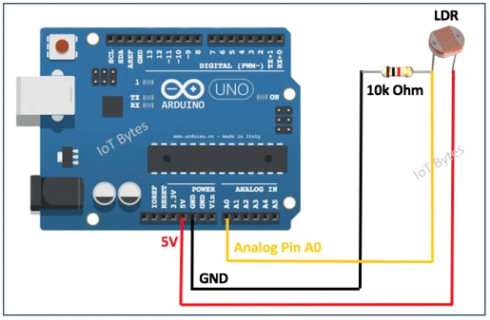

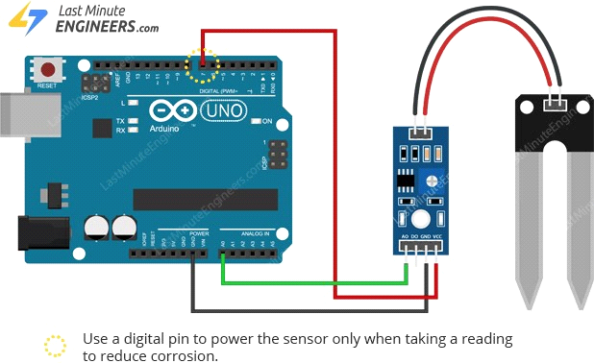



* Implementation Sensor code
* LDR senor
* DHT sensor
* Moisture sensor
* Testing code on Arduino using serial monitor
* Implementing final code output on LCD
* Hardware Implementation of all components like LCD , Arduino, Sensor , FAN etc.
* Note LUX light meter value at 8.26 am , 12.45 pm , 5.26 pm

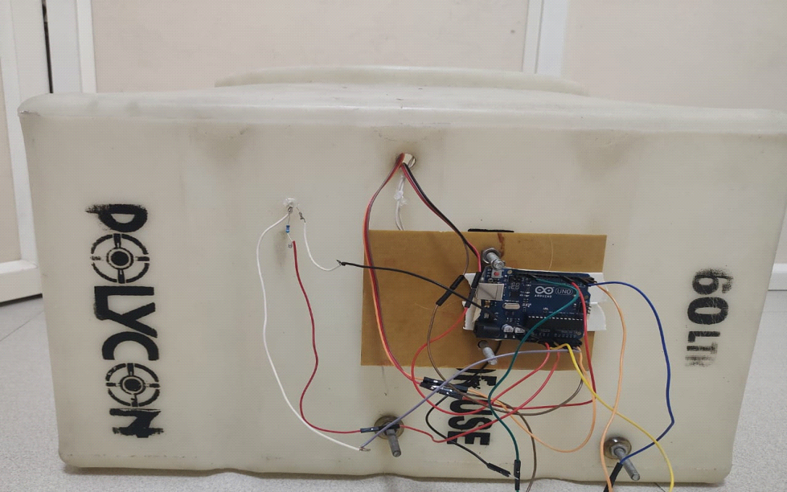

**Code start**

#include <dht.h>

#include <Wire.h>

#include <LiquidCrystal_I2C.h>

LiquidCrystal_I2C lcd(0x27, 20, 4);

#define dht_pin A0 // Analog Pin A0 of Arduino is connected to DHT11 out pin

#define moist A2 // Analog Pin A2 of Arduino is connected to moisture out pin

#define LDR A1 // Analog Pin A1 of Arduino is connected to LDR out pin

dht DHT;

void setup()

{

pinMode(2, OUTPUT);

pinMode(4, OUTPUT);

pinMode(8, OUTPUT);

pinMode(9, OUTPUT);

pinMode(A1, INPUT);

pinMode(A2, INPUT);

lcd.begin();

lcd.backlight();

lcd.clear();

}

void loop()

{

// LED Code Start

digitalWrite(2, HIGH);

digitalWrite(4, HIGH);

// Fan Code Start

DHT.read11(dht_pin);

if (DHT.temperature > 24.0)

{

digitalWrite(8, HIGH); // Turn on the fan

digitalWrite(9, LOW);

}

else

{

digitalWrite(8, LOW); // Turn off the fan

digitalWrite(9, HIGH);

}

lcd.print("Humidity = ");

lcd.print(DHT.humidity);

lcd.print("%");

lcd.setCursor(0, 0);

delay(500);

lcd.print("Temperature = ");

lcd.print(DHT.temperature);

lcd.setCursor(0, 1);

delay(500);

int val = analogRead(A1); // Read the analog value from the sensor

lcd.print("Moisture = ");

lcd.print(val);

lcd.setCursor(0, 2);

int LDRReading = analogRead(A2);

lcd.print("LDR = ");

lcd.print(LDRReading);

lcd.setCursor(0, 3);

delay(500);

**}**

**Problem in Project implementation**

* Code Merge
* Power Supply like 5v pin and ground pin.
* Serial Monitor code to LCD Code using I2C
* Calculation of Light Intensity at Different time .Using LUX meter

**Lux App Data @ value at 8.22 am , 12.45 pm , 5.26 pm**

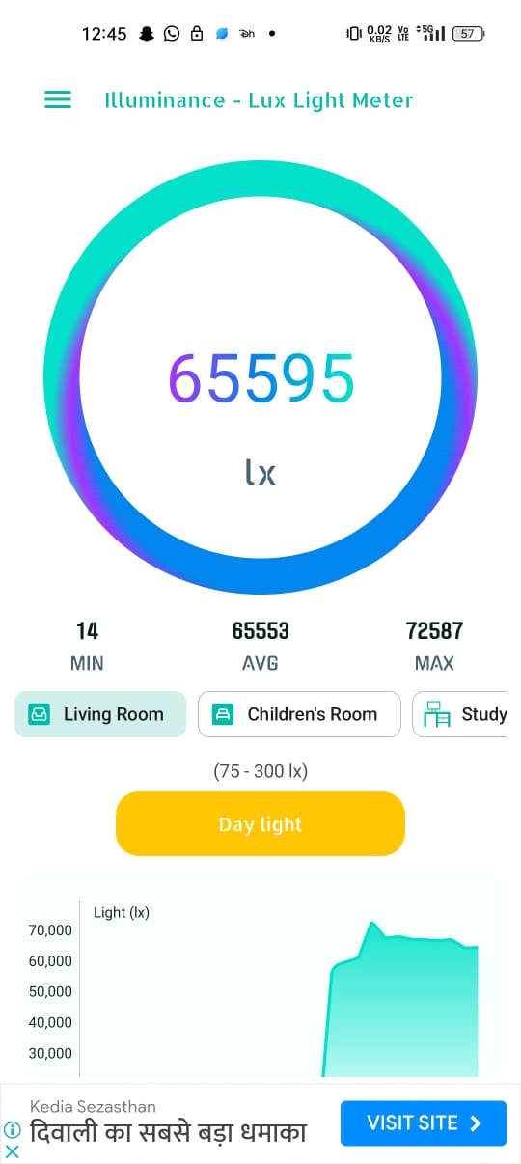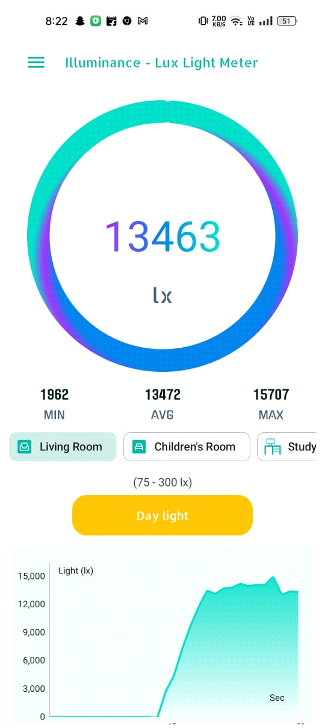

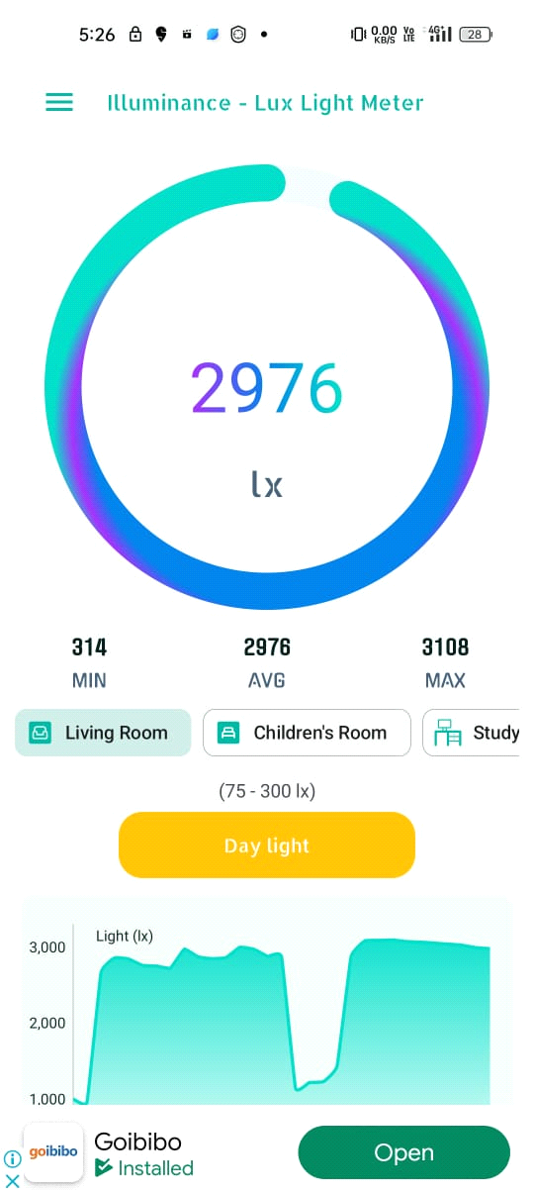

**Final project Implementation**

­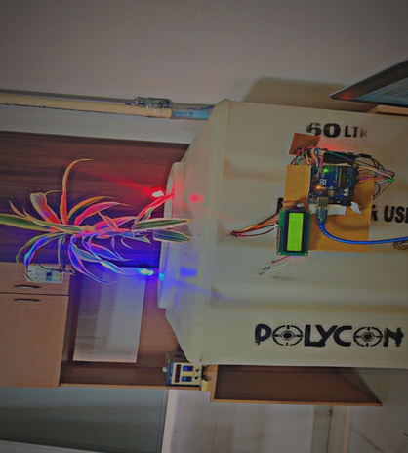

**FURTHER IMPLEMENTATION**

* Create different artificial enviornment as per need.
* Also connect the project with thingsboard over the cloud/Internet.

**Contacts:**

For further inquiries or support ,please Contact Rikvender singh